Introduction
Welcome to your interactive workbook companion for “Designing a Profitable Business Model.” This workbook is designed to reinforce key concepts, challenge your understanding, and help you apply the strategies learned in the book to your own business ventures. Through a variety of exercises, you’ll deepen your knowledge and develop practical skills essential for crafting a successful business model.
Let’s begin our journey towards building a thriving, profitable business!

Chapter 1: Identifying Lucrative Revenue Streams

Learning Objectives:
- Understand the importance of diverse revenue streams
- Identify potential revenue sources for your business
- Assess market demand and customer payment behaviors
- Align revenue streams with business objectives
- Create a balanced revenue portfolio

Exercise 1: Revenue Stream Brainstorming
List at least 5 potential revenue streams for your business idea. Consider both primary and secondary sources of income.

Exercise 2: Market Demand Assessment
For each revenue stream you identified, rate the potential market demand on a scale of 1-5 (1 being lowest, 5 being highest). Briefly explain your rating.
Revenue Stream | Market Demand (1-5) | Explanation

Exercise 3: Customer Payment Behavior
Research and describe the preferred payment methods for your target market. How might this impact your revenue model?
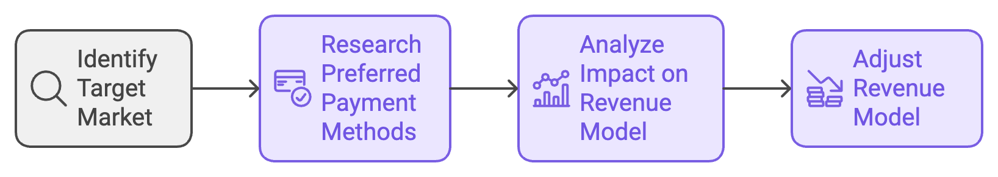

Exercise 4: Aligning Revenue Streams with Business Objectives
Choose your top 3 revenue streams and explain how each aligns with your overall business objectives.
- Revenue Stream: ______________________________
Alignment: __________________________________________________________
- Revenue Stream: ______________________________
Alignment: __________________________________________________________
- Revenue Stream: ______________________________
Alignment: __________________________________________________________

Exercise 5: Revenue Portfolio Diversification
Create a pie chart representing your ideal revenue mix. Ensure it’s diversified to mitigate risks.
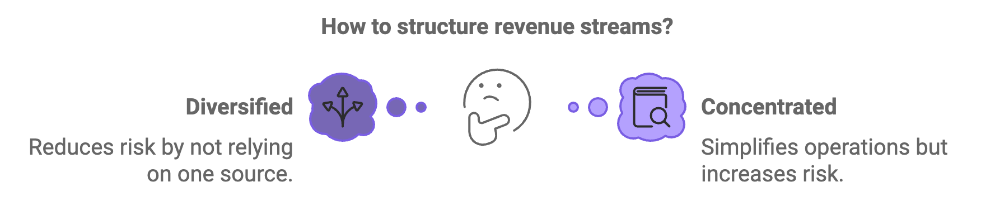
[Insert a blank circle here for the student to draw their pie chart]

Exercise 6: Case Study Analysis
Read the following case study and answer the questions below:
“TechGear, a startup selling smartphone accessories, initially relied solely on direct online sales. After six months, they noticed stagnating growth. They decided to diversify their revenue streams by introducing a subscription model for premium phone cases, partnering with physical retail stores, and offering white-label products to other brands.”
a) What challenges might TechGear have faced with their initial single revenue stream?
b) How does each new revenue stream potentially address these challenges?
c) What risks might be associated with each new revenue stream?
d) How could TechGear test these new revenue streams before fully implementing them?

Exercise 7: Reflection
Consider the revenue streams you’ve identified for your business. What potential obstacles might you face in implementing these streams? How can you prepare to overcome these obstacles?

Chapter 2: Crafting a Compelling Value Proposition

Learning Objectives:
- Understand the components of an effective value proposition
- Conduct customer research and competitive analysis
- Use the Value Proposition Canvas
- Craft a clear and compelling value proposition statement
- Test and refine your value proposition

Exercise 1: Value Proposition Components
Fill in the blanks with the correct components of a value proposition:
A strong value proposition should address ____________, quantify ____________, and highlight ____________ differentiation.

Exercise 2: Customer Research
Describe three methods you could use to gather deep insights about your target customers’ needs, pain points, and desires.

Exercise 3: Competitive Analysis
Create a simple competitive analysis matrix for your business idea and two main competitors. Rate each (including your business) on a scale of 1-5 for key features or benefits.
Feature/Benefit | Your Business | Competitor 1 | Competitor 2

Exercise 4: Value Proposition Canvas
Fill out a simplified Value Proposition Canvas for your business idea:
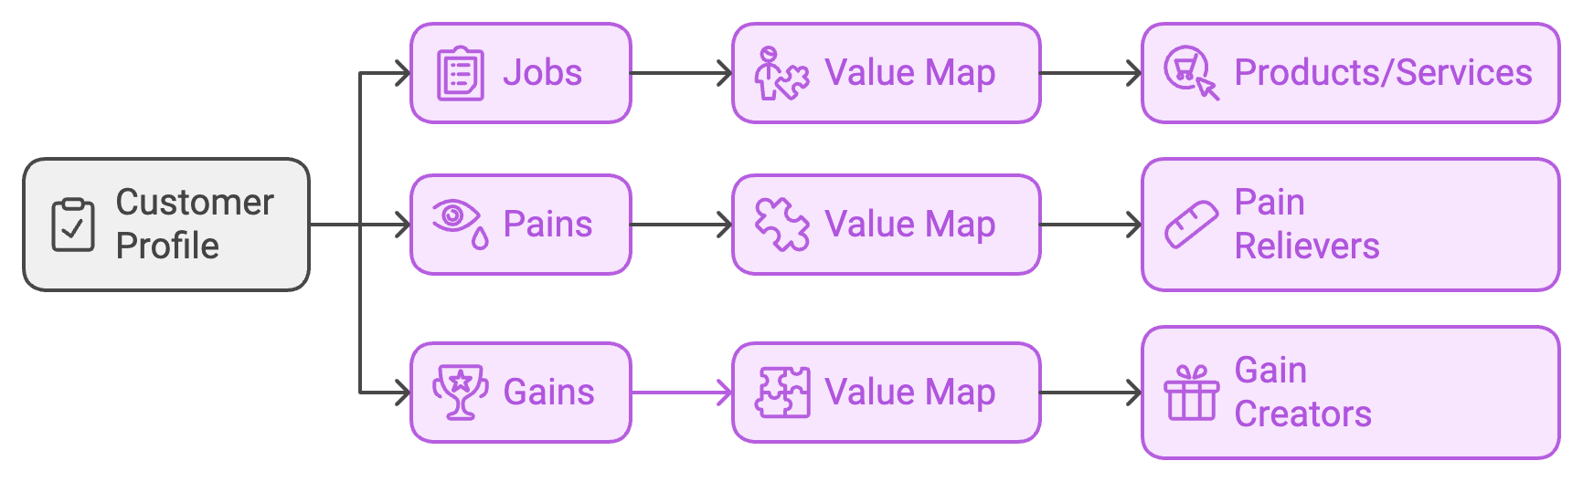
Customer Profile:
- Jobs: ______________________________________________________
- Pains: _____________________________________________________
- Gains: _____________________________________________________
Value Map:
- Products/Services: ____________________________________________
- Pain Relievers: _______________________________________________
- Gain Creators: _______________________________________________

Exercise 5: Crafting Your Value Proposition Statement
Using the formula provided in the book, craft a value proposition statement for your business:
For _____________________________________________________________
Who ____________________________________________________________
Our _____________________________________________________________
That ____________________________________________________________

Exercise 6: Testing Your Value Proposition
Describe two methods you could use to test the effectiveness of your value proposition:
- ___________________________________________________________
How it works: ________________________________________________
- ___________________________________________________________
How it works: ________________________________________________

Exercise 7: Case Study Analysis
Read the following value proposition from Dollar Shave Club:
“A great shave for a few bucks a month. No commitment. No fees. No BS.”
a) Identify the components of this value proposition (relevancy, quantified value, unique differentiation).
b) Who is the target customer for this value proposition?
c) How does this value proposition address potential customer pain points?
d) If you were a competitor, how might you create a distinctive value proposition to compete with Dollar Shave Club?

Exercise 8: Reflection
Reflect on your value proposition. How confident are you that it truly resonates with your target customers? What additional information or insights might you need to refine it further?

Chapter 3: Aligning Resources and Activities for Sustainable Income
Learning Objectives:
- Understand strategic resource allocation
- Optimize business processes for efficiency
- Establish key partnerships
- Manage cash flow effectively
- Scale responsibly

Exercise 1: Resource Allocation
For your business idea, list key resources in each category and briefly describe how you would allocate them:
Financial Resources:

Human Resources:

Technological Resources:

Exercise 2: Process Optimization
Identify a key business process in your industry and describe how you could optimize it using lean principles.
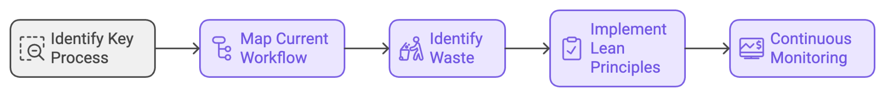
Process: _________________________________________________________
Optimization strategy:

Exercise 3: Key Partnerships
Complete the following table to identify potential key partners for your business:
Partner Type | Potential Partner | Value They Provide | Value You Provide

Exercise 4: Cash Flow Management
List five strategies you could implement to improve cash flow management in your business:

Exercise 5: Responsible Scaling
Describe three potential risks of scaling too quickly and how you might mitigate each:
- Risk: __________________________
Mitigation: ___________________________________________________
- Risk: __________________________
Mitigation: ___________________________________________________
- Risk: __________________________
Mitigation: ___________________________________________________
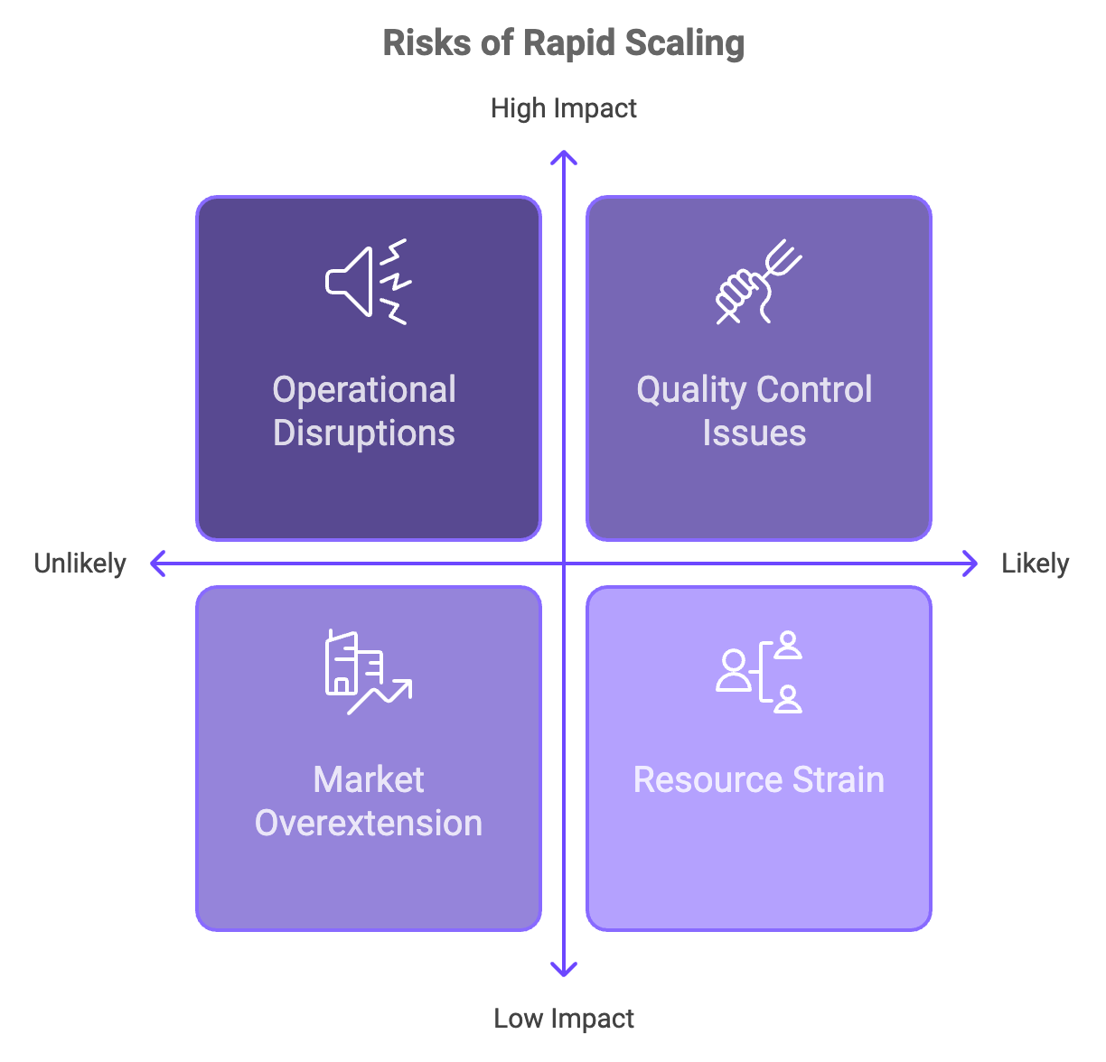

Exercise 6: Case Study Analysis
Read the following scenario and answer the questions below:
“GreenGrow, an urban farming startup, has been experiencing rapid growth. They’re considering expanding to three new cities, doubling their workforce, and investing in new hydroponic technology. However, they’re concerned about maintaining their quality and company culture while scaling.”
a) What potential challenges might GreenGrow face in this expansion?
b) How could they allocate their resources effectively to support this growth?
c) What processes might they need to optimize or standardize?
d) What types of partnerships could help them scale more efficiently?
e) How could they manage their cash flow during this expansion phase?

Exercise 7: Reflection
Consider your own business idea. What do you see as the biggest challenge in aligning your resources and activities for sustainable income? How might you address this challenge?

Chapter 4: Strategies for Testing and Refining Your Business Model

Learning Objectives:
- Understand the importance of continuous improvement
- Implement A/B testing effectively
- Create customer feedback loops
- Apply the Minimum Viable Product (MVP) strategy
- Recognize when and how to pivot
- Interpret data for business model refinement

Exercise 1: A/B Testing
Design an A/B test for a key element of your business model. Complete the following:
Element to test: ___________________________________________________
Version A: ________________________________________________________
Version B: ________________________________________________________
Key Performance Indicator (KPI) to measure: ____________________________
How you’ll ensure statistical significance: _______________________________
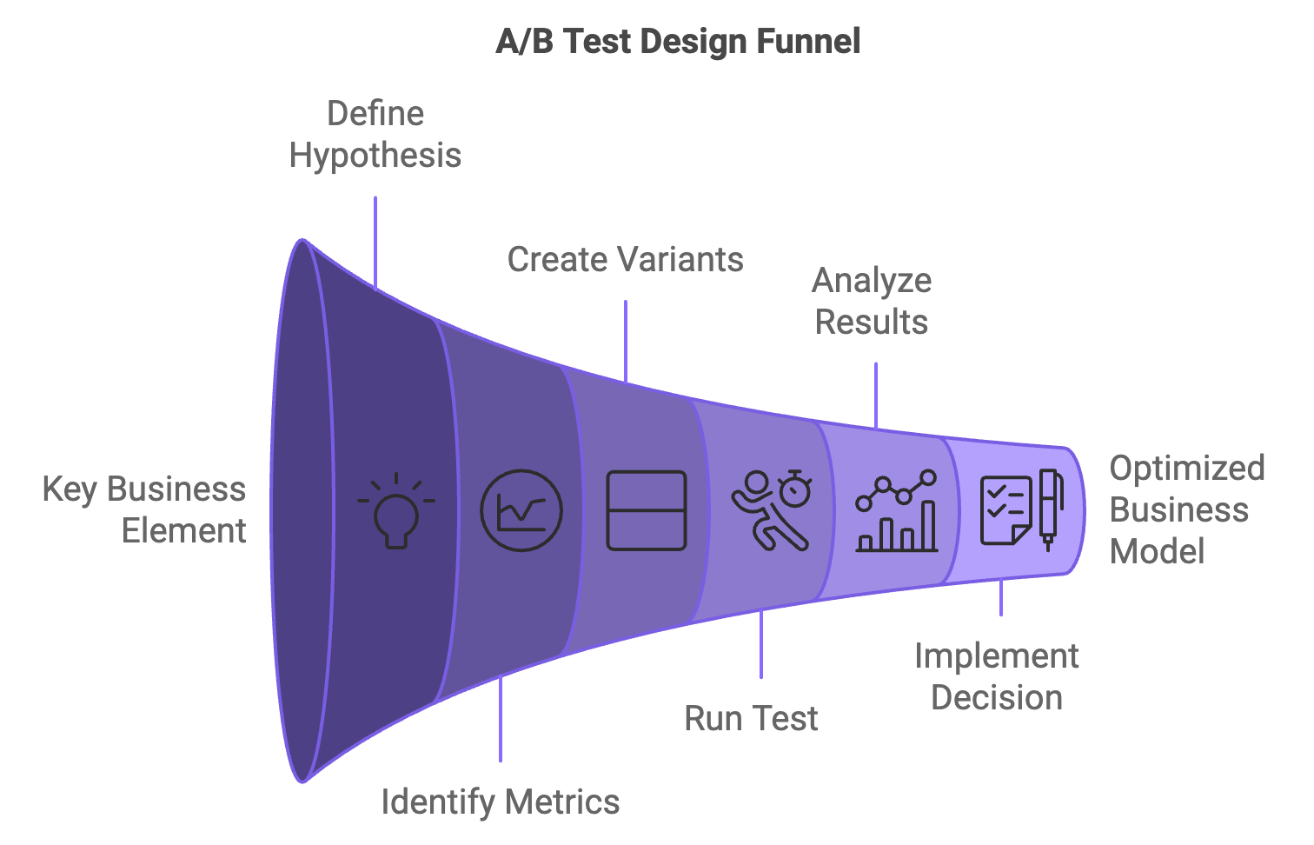

Exercise 2: Customer Feedback Loops
List three methods you could use to gather customer feedback and explain how you would implement each:
- Method: ___________________________
Implementation: ______________________________________________
- Method: ___________________________
Implementation: ______________________________________________
- Method: ___________________________
Implementation: _____________________________________________

Exercise 3: Minimum Viable Product (MVP)
Describe an MVP for your business idea:
Core value proposition: _____________________________________________
Minimum features required: __________________________________________
How you’ll gather feedback: __________________________________________

Exercise 4: Pivoting
Identify three potential pivot scenarios for your business and the type of pivot for each:
- Scenario: ___________________________________________________
Type of pivot: ________________________________________________
- Scenario: ___________________________________________________
Type of pivot: ________________________________________________
- Scenario: ___________________________________________________
Type of pivot: ________________________________________________

Exercise 5: Data Interpretation
You run an online course platform and have the following data:
- Course completion rate: 45%
- Average time spent on platform per week: 2.5 hours
- Customer acquisition cost: $50
- Lifetime customer value: $200
- Churn rate: 15% per month
What insights can you draw from this data? What changes might you consider making to your business model based on these insights?

Exercise 6: Case Study Analysis
Read the following case study and answer the questions below:
“FitTech, a fitness app startup, launched with a focus on providing personalized workout plans. After six months, they noticed high initial downloads but low retention rates. Through customer feedback, they learned that users were struggling to stay motivated. They decided to pivot by adding social features, allowing users to connect with friends, join challenges, and share achievements.”
a) What testing methods could FitTech have used to identify the problem earlier?
b) How might they have applied the MVP strategy in their initial launch?
c) Describe how they could use A/B testing to validate their pivot decision.
d) What customer feedback loops could they implement to continue refining their model?
e) How might they measure the success of their pivot?

Exercise 7: Reflection
Reflect on your approach to testing and refining your business model. What areas do you feel most confident about? Where do you think you need to improve? How can you cultivate a culture of experimentation in your business?

Glossary of Key Terms
- A/B Testing:
- Business Model:
- Cash Flow:
- Minimum Viable Product (MVP):
- Pivot:
- Revenue Stream:
- Value Proposition:

