WRITING THAT STICKS GUIDE
____

Introduction
In an information-saturated world, creating content that captures attention and inspires action is more essential than ever. This complete guide distills key principles into actionable strategies designed to make your business writing truly memorable.
The core concept is simple yet powerful: effective writing combines clear purpose, strong hooks, rhythmic flow, and psychological engagement to create content that resonates deeply with readers and inspires action. This guide will show you exactly how to implement these elements in your writing.

Establishing Your Writing Foundation

Define Your Purpose
Before writing anything, clearly establish:
- Core Message:
- What’s the one thing readers must remember?
- What specific value are you providing?
- How will this piece change your readers’ thinking or behavior?
- Target Audience:
- Create detailed reader personas
- Identify their pain points and aspirations
- Understand their current knowledge level
- Desired Outcome:
- What specific action should readers take?
- How will you measure success?
- What emotional response do you want to evoke?

Implementation Exercise:
Create a purpose statement template:
I am writing this [type of content]
For [specific audience]
To [desired outcome]
After reading, they should feel [emotion]
And be motivated to [action]

Craft Your Message Strategy
- Core Components:
- Main argument or thesis
- Supporting evidence
- Call to action
- Content Structure:
- Introduction (hook and context)
- Body (main points and evidence)
- Conclusion (synthesis and next steps)
- Success Metrics:
- Engagement indicators
- Conversion goals
- Feedback mechanisms

Creating Irresistible Hooks

Opening Techniques
- The Question Method:
- Challenge assumptions
- Provoke thought
- Create curiosity
Example: “What if everything you knew about customer engagement was wrong?”
- The Contrast Method:
- Present opposing ideas
- Highlight unexpected connections
- Create cognitive dissonance
Example: “Most businesses fail at social media. Yet the solution is simpler than you think.”
- The Story Method:
- Start with a relevant anecdote
- Create emotional connection
- Illustrate key points through narrative

Implementation Exercise:
Write five different openings for your next piece using each technique. Test them with a small audience to determine the most effective approach.

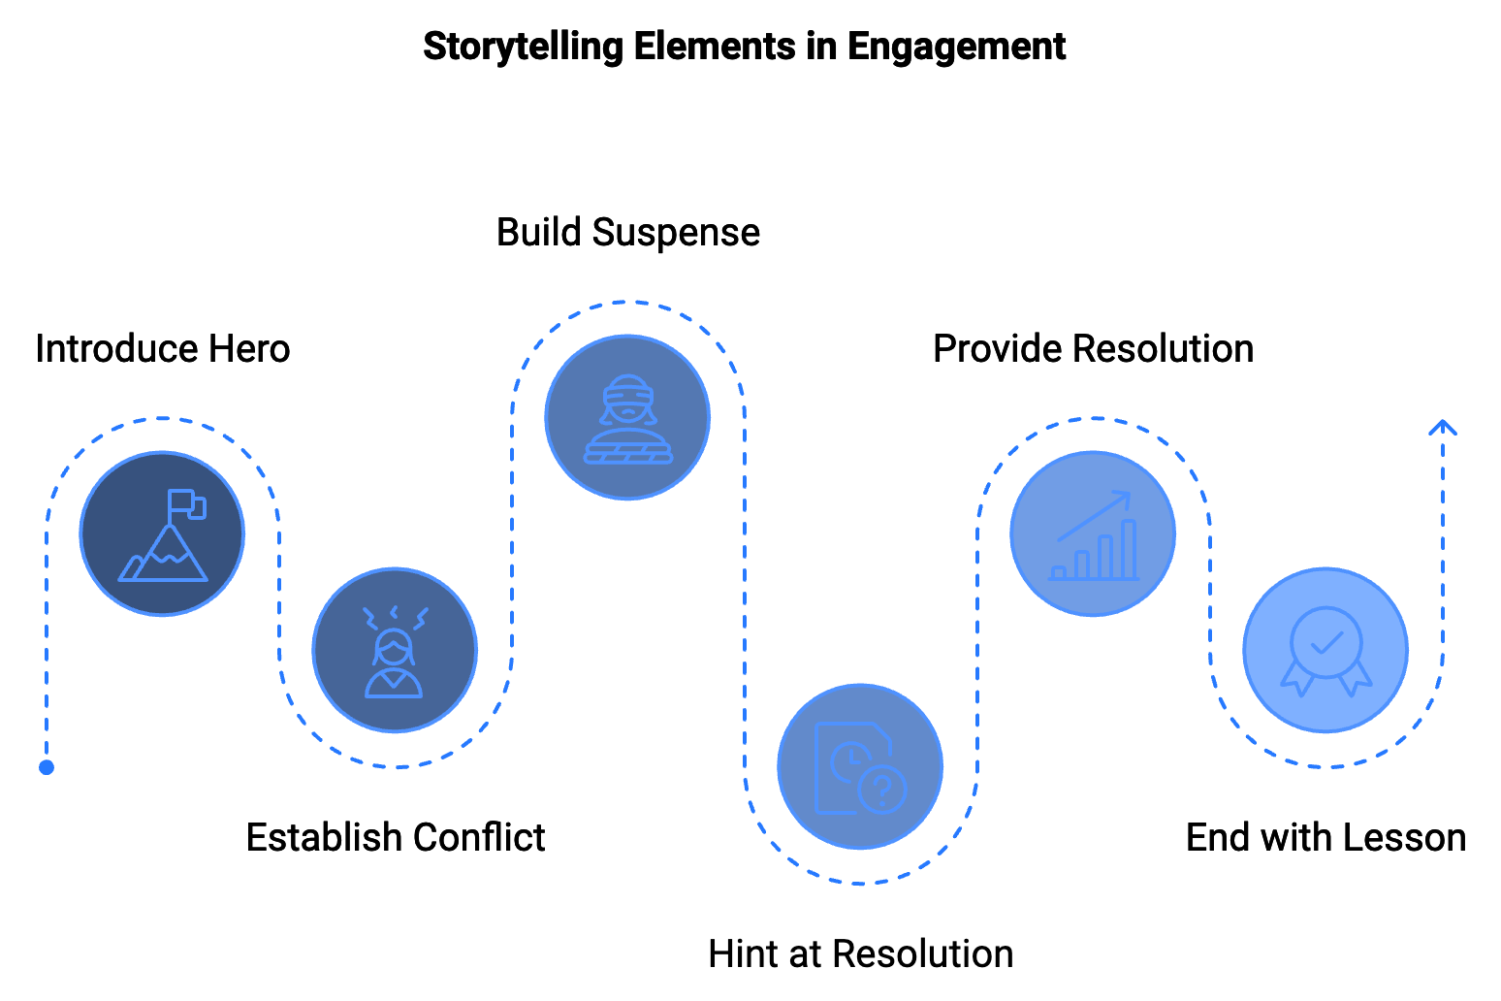

Maintaining Engagement
- Curiosity Gaps:
- Tease information
- Create anticipation
- Promise valuable insights
- Pattern Interrupts:
- Vary sentence structure
- Include unexpected elements
- Use strategic formatting
- Momentum Builders:
- Transitional phrases
- Question sequences
- Progressive revelation

Mastering Flow and Rhythm

Sentence Structure Techniques
- Length Variation:
- Very short (1-5 words)
- Short (6-10 words)
- Medium (11-20 words)
- Long (20+ words)
- Rhythm Patterns:
- Statement-Question
- Problem-Solution
- Setup-Payoff
- Transition Types:
- Logical connections
- Temporal sequences
- Contrast relationships

Implementation Exercise:
Analyze your recent writing:
- Highlight sentences by length category
- Identify patterns and repetition
- Revise for optimal flow

Visual Flow Elements
- Formatting Tools:
- Headings and subheadings
- Bullet points and lists
- White space management
- Emphasis Techniques:
- Bold key concepts
- Italicize supporting points
- Use callout boxes
- Structural Patterns:
- Information hierarchy
- Progressive disclosure
- Scannable layouts

Psychological Engagement

Emotional Connection Strategies
- Language Choice:
- Power words
- Emotional triggers
- Sensory details
- Story Elements:
- Character development
- Conflict resolution
- Personal transformation
- Trust Building:
- Social proof
- Authority markers
- Transparency indicators

Persuasion Principles
- Reciprocity:
- Provide value first
- Share insights freely
- Offer useful resources
- Consistency:
- Align with reader values
- Build on existing beliefs
- Create commitment loops
- Social Proof:
- Include testimonials
- Share case studies
- Reference statistics

Implementation Exercise:
Create a persuasion checklist:
- Identified emotional triggers
- Incorporated stories
- Added social proof
- Created value proposition
- Included call to action
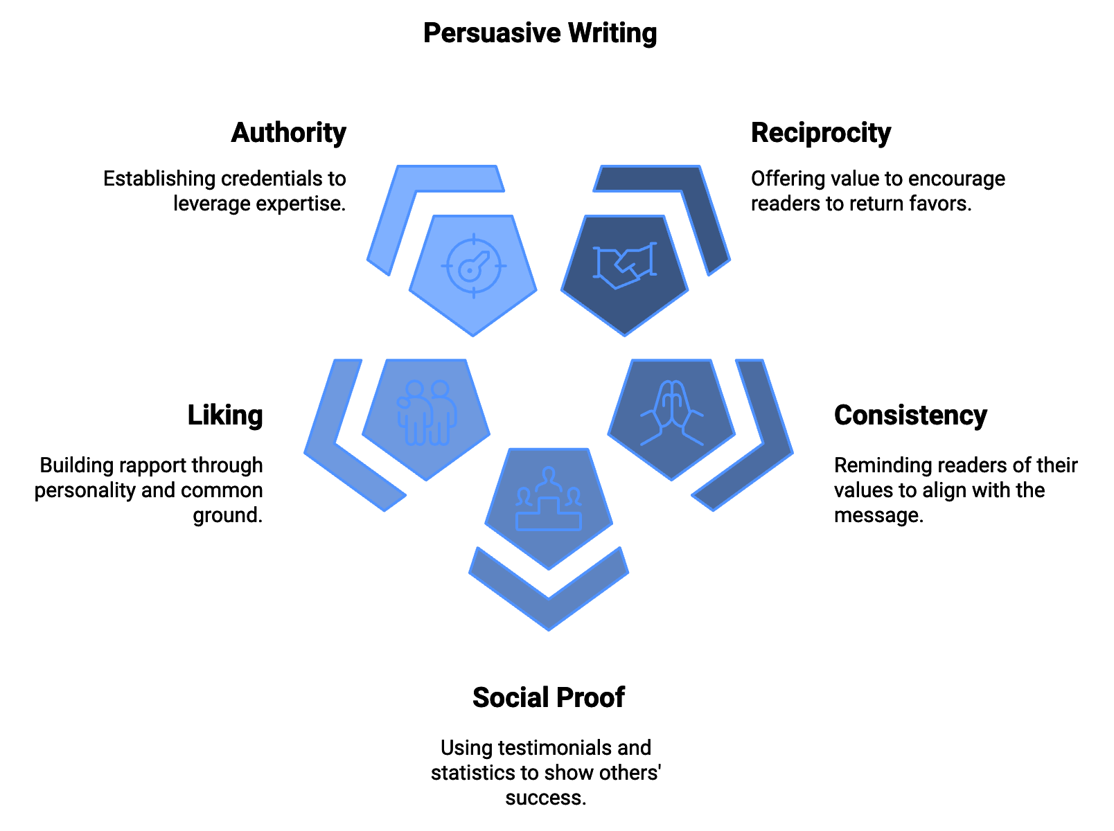

Part 5: Implementation Framework

Writing Process
- Preparation Phase:
- Purpose definition
- Audience analysis
- Content research
- Creation Phase:
- Outline development
- First draft writing
- Initial revision
- Refinement Phase:
- Peer review
- Final editing
- Publication preparation

Quality Control
- Content Checklist:
- Purpose alignment
- Message clarity
- Flow assessment
- Emotional impact
- Call to action effectiveness
- Technical Checklist:
- Grammar and spelling
- Formatting consistency
- Link functionality
- Mobile responsiveness
- Impact Measurement:
- Engagement metrics
- Conversion tracking
- Reader feedback

Action Plan
- Immediate Steps:
- Complete the purpose statement template
- Create your first hook collection
- Practice sentence variation exercises
- Week One:
- Write three pieces using new techniques
- Gather feedback from target readers
- Refine based on responses
- Month One:
- Build your writing system
- Develop style guide
- Create content calendar
- Ongoing Development:
- Regular writing practice
- Continuous improvement
- Skill expansion

Conclusion
Creating writing that sticks requires a systematic approach combining purpose, technique, and psychology. By implementing these strategies consistently, you’ll develop content that not only captures attention but drives meaningful action.
Remember:
- Start with clear purpose
- Focus on strong hooks
- Maintain engaging flow
- Connect emotionally
- Drive specific actions
Your next piece of writing is an opportunity to put these principles into practice. Begin with the purpose statement template and work through each element systematically. Success in writing that sticks comes from consistent application of these proven techniques.
Start implementing these strategies today, and watch your writing transform from ordinary to extraordinary.

